**THE MAIN INFLUENCING FACTORS OF MOBILE BANKING ADOPTION IN THE OPEN INNOVATION BUSINESS ENVIRONMENT (CASE STUDY)**

**Author(s):**

T. Atobishi 1, M. Bahna 1, Cs. Fogarassy 2

**Affiliation:**

1 Doctoral School of Management and Business Administration – Hungarian University of Agriculture and Life Sciences, 2100 Gödöllő, Páter Károly u. 1., Hungary;

2 Institute of Agriculture and Food Economics - Hungarian University of Agriculture and Life Sciences, 2100 Gödöllő, Páter Károly u. 1., Hungary;

**Email address:**

thabet.tubashi@moj.gov.jo; miriam.bahna@phd.uni-mate.hu; fogarassy.csaba@uni-mate.hu

**Abstract:** Mobile banking is a mobile commerce application that is revolutionizing financial services. Accepting and using a virtual system is not easy for users, either technologically or emotionally. The purpose of this research is to find out the effects of "Effect of Risk Perception", "Perceived Ease of Use" and "Perceived Usefulness of Mobile Banking" on mobile banking attitude and adoption. For this study, data was collected in 2019 from N=220 participants using 19 items of five Likert-type questionnaires. The data was analyzed using Statistical Package for Social Sciences and Regression Analysis through the enter method was used. It was found out that there is a positive significant effect of perceived ease of use and perceived usefulness of mobile banking on mobile banking attitude. The results also showed, that attitude towards switching to mobile banking has a positive significant effect on the intentions of mobile banking adoption. It can be concluded that the perceived ease of use of mobile banking will have a significant impact on attitudes towards switching to mobile banking services. The results of the research show that the perceived risk has a significant effect on the mobile. Also, for the practitioners it is very important to take into consideration these results to promote the usage of mobile banking among the customers in Jordan. Our research results also show similarities and differences from previous research results, confirming the unique characteristics of the rapidly developing Arab region. User behavior related to mobile banking is shaped by the combined effect of custom and culture. Mobile banking services may be a very efficient and cost-effective tool in the future, accelerating industry development processes.

**Keywords:** mobile banking; technology adoption; consumer behavior; technology acceptance; behavior intention

# 1. Introduction

Electronic banking is a huge step in the field of finance [1]. It can be a useful tool for the banks to improve their relations with the customers through enhancing the customer loyalty, affective commitment and the satisfaction [2]. Although still mobile banking started adoption from only 1999 and now everyone uses mobile banking to make transactions and to send and receive payments or to purchase products. Mobile banking is “instance of a mobile commerce (commerce) application by which financial institutions enable their customers to carry out banking activities via mobile devices” [3]. In every decade various scientific changes occur similarly now mobile banking is giving ease and enhancing its services everyone is involved either as a user or a service provider [4] mortgage and credit cards play a vital role in influencing the use of electronic banking [5]. However, in research inter-net banking is further divided into three phases the first is to analysis and to know what is internet banking also known as descriptive type, second is to adopt internet banking after understanding it and by using it also known as relational. The third type is comparing two or more types of internet banking to conclude better results and improve this technology in the better way known as comparative [6]. In the very beginning this area was not focused to attain the betterment, but now it is expanding exponentially. The internet banking even introducing few new or improved methods to be used in the financial and banking sector, such models and theories like TAM (Technology Acceptance Model), Structural Equation Modeling (SEM), Unified Theory of Acceptance and Usage of Technology (UTAUT), Task-Technology Fit (TTF), Initial Trust Model (ITM), diffusion of innovation theory, unified technology acceptance theory and various such theories were presented to improve mobile banking adoption [7]. In Jordan mobile banking services are growing rapidly and the growth rate jumped to 140% in 2012 [8], also the study by Gharaibeh, Arshad, & Gharaibeh [9] showed that only 8% of the banks customers in Jordan have used the mobile banking services and according to the 2019 digital financial country report 79% used the mobile devices to conduct their banking transactions. In the Jordanian economy 44% of the small enterprises would not use the digital financial services in their businesses, also the report assured that Jordan has a fine digital financial services foundation due to its modern ICT infrastructure and adequate regulations (Digital Finance Country Report Jordan, 2019). However, the use of smart phones shows a different picture in the country. According to the report [10] in Jordan mobile banking took over the e-banking and became more popular, but unfortunately the usage of mobile banking (with safety smart phones) is still at low-level and only 2% of adults used mobile banking. The report showed that culture, cost and low technological knowledge level of the customers are the main obstacles for usage of mobile banking services. In this study we empirically tested the major factors affecting the customers’ adoption of the mobile service banking in Jordanian market. Our research question was what main factors (risk perception, the perceived easy of using, usefulness and the technology acceptance attitude) influence the use of mobile banking services in the context of mobile phone use in rapidly evolving economic systems.

2. The Technology Acceptance Model (TAM) and other adoptions theoretical concepts

Mobile banking can be defined as “Mobile banking, also referred to as cell phone banking, is the use of mobile terminals such as cell phones and Personal Digital Assistants (PDAs) to access banking networks via the Wireless Application Protocol (WAP)” [11]. Mobile banking is adding a facility for the users it is being used to deploy betterment in business and even in the daily routine. The main advantage of providing mobile banking is to enable the customers to make transactions at any place and time [12].

The adoption of mobile banking is expanding exponentially, it is witnessed that the demand and the user both are increasing in the same ratio. Various applications and products use the internet or mobile banking to increase their sell ratio. In a sur-vey, it was reported that eighty percent of people are now using their mobile banking, and it is increased sixty percent as compared with previous years [13]. The significant increase in the use of mobile banking needs a comparatively strong architect to de-sign the models for mobile banking and to be adopted as well. In terms of financial usage, automated teller machines known as ATM were used widely from last decade and give growth to internet banking [14]. However, the current era is dealing with mobile adoption as the use of mobile is increased exponentially similarly mobile banking is increased as it saves the time in transactions and it is also a secure method to transfer or to withdraw amount or to purchase products [15]. In other fast developing countries, for example the statistics from Malaysia show enormousness of smart mobiles usage which reported that 65% of population of Malaysia owns mobile phones [16]. A study by Alalwan, Dwivedi, Rana, & Williams [8] about consumer adoption of mobile banking in Jordan showed that perceived usefulness, perceived ease of use and perceived risk are significantly influence the behavioral intention to use mobile banking. Furthermore, this leads the innovation models, to tackle mobile adoption in the banking sector and integrate the innovative tools to emerging technology in one place [17]. While discussing the innovation models the previous methods have limited prediction power to tackle innovative technical change in the field of internet banking, to relate cross co-relation [18].

TAM (Technology Acceptance Model) was an effective model used to predict the new information and the adoption in the new information of the technologies. The proposed TAM (Technology Acceptance Model) process is shown in the Figure 1.

It is one of the most used models at individualistic level and has been proved in term of validity by many studies [20], [21], [22]

Basically, it was based on the model Theory of Reasoned Action (TRA) and later on it was improved and the new model was known as TAM [23]. The similarity of TAM with other models is still a part but considered as a better solution than other models. As TAM is based on TRA the basic aim of the developing this model was to make further predictions, to use with new technical systems [4]. TAM operates to provide benefits given by the information systems and parsimonious, and innovation [24]. The adoption rate basically depends on the five basic things complexity, compatibility, trainability, relative advantage, and observability as this theory is the oldest and known as diffusion of innovation theory. Similarly, the theory of planned behavior model improves the predictive power [25]. This theory of planned behavior base on attitude, subjective norm, perceived behavioral control, and these three basic modules then processed with intentions and by this behavior is judged. Likewise, like the theory of planned behavior the diffusion of innovation theory explains, what, how, when and why the new mobile adoption and the technology are spreading. This theory explains the process of diffusion is like the innovation communication depends on the time and the users in the social circle [26]. The most complete model Decomposed Theory of Planned Behavior DTPB, known as an improved model and based on the innovation diffusion theory, it is a multidimensional solution and considered as having multi-impact factors in the adoption of the technology. Decomposed Theory of Planned Behavior has two peer constructs peer influence and superior influence [27]. These all theories explain how, when and why the mobile adoption is increasing its use, increasing its popularity, and demand. As the technology is advancing, and changing diversely and adopting new technical changes in mobile banking is already been adopted widely. The excessive number of users now making it hard to remain constant, there is a need to adopt new technical changes and enhance the abilities of mobile banking, the previous models are already performing for what they were developed, but there is a need to improve the models to handle such increased users [28], [29]. The mobile adoption is increased and needs the models to improve and give same and better results for the users. The sudden need to improve models is because of the exponential increase in the users and their requirements according to the current era. So TAM model has been extended or modified by many scholars and these new versions of the TAM model is called TAM++ [30], trust and perceived risk were among the most used factors in extended the TAM model [2].

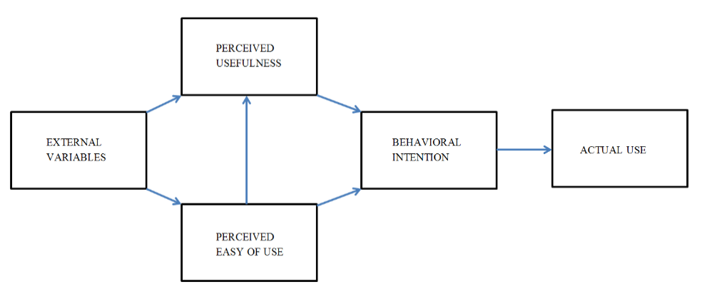

*Figure 1.* Proposed Technology Acceptance Model (TAM)[[19].

In mobile banking adoption to analyses the current technical aspects as a unified view, the theory of unified acceptance and the use of the technology will be used [31]. To analyze the facilitating condition, performance expectancy, social influence, and effort expectancy, of the mobile banking unified theory of acceptance will perform better than other theories, like TPB (theory of planned behavior), DTPB (decomposed theory of planned behavior), TRA (theory of reasoned action) [32]. Unified theory acceptance is basically a technology acceptance model, this analyzes the unified view, and this theory explains the user intentions to use in the subsequent behavior of the user. To analyze the direct determinants in mobile banking adoption and the user behavior the best theory and the model is a unified theory of acceptance [25]. The improvement in the models and the study can be brought in the field of mobile banking adoption by the unified theory of acceptance [17].

The Unified Theory of Acceptance and Use of Technology (UTAUT) covered various gaps in terms of integration, and in the need of mobile banking adoption to overcome gaps of understanding between the banks and the clients. The UTAUT improved mobile bank services by providing services accordingly, by this perceived risk is reduced [33], [34], [35], [36] . The detailed UTAUT process is shown in the Figure 2. Though the unified theory of acceptance new model was built to improve the mobile banking adoption, previously it was discussed as theory and the practical work was not found. However, after the implementation of the unified theory various perspectives were now overcome but after an exponential increase in the users, various certain and uncertain gaps were still there. The unified theory of acceptance improved the interacting behavior with the clients, by including the emergence of technology, and by implementing [4],[37]. Previous it was observed that UTAUT was capable of working two different cultural environments like, in the developing country and in a developed country. Similarly, it is concluded that now it is the time to test the UTAUT model that it could be able to tackle such exponential load of users and data. It can be now tested or checked that the UTAUT model still has the power to tackle and to produce the same high results [4].

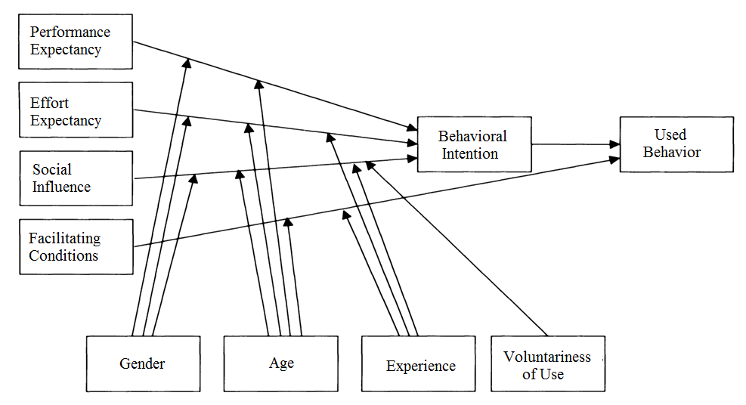

*Figure 2.* Proposed UTAUT [4].

New research may be conducted to test if UTAUT needs improvements in its model, either there should be a need to improve its predictive power of the UTAUT [38],[39]. The security concerns always appear in the adoption of new technologies especially if it’s related to the applications of e-commerce. The perceived risk theory has been used to investigate the consumer’s behaviour especially in online purchasing, the perceived risk of online banking can be seen in five dimensions: Security/privacy risk, financial risk, Social risk, Time/convenience risk and Performance risk [40]. According to Featherman and Pavlou [35], perceived risk is can be defined as "the potential for loss in the pursuit of a desired out-come of using an e-service” (Figure 3.).



*Figure 3.* Proposed model based on Featherman & Pavlou [41]

After reviewing the previous studies we propose the following research framework by integrating the TAM model with perceived risk factor. Security (risk perception), perceived ease of use and perceived usefulness were the starting points in the design of the test framework (Figure 4.).

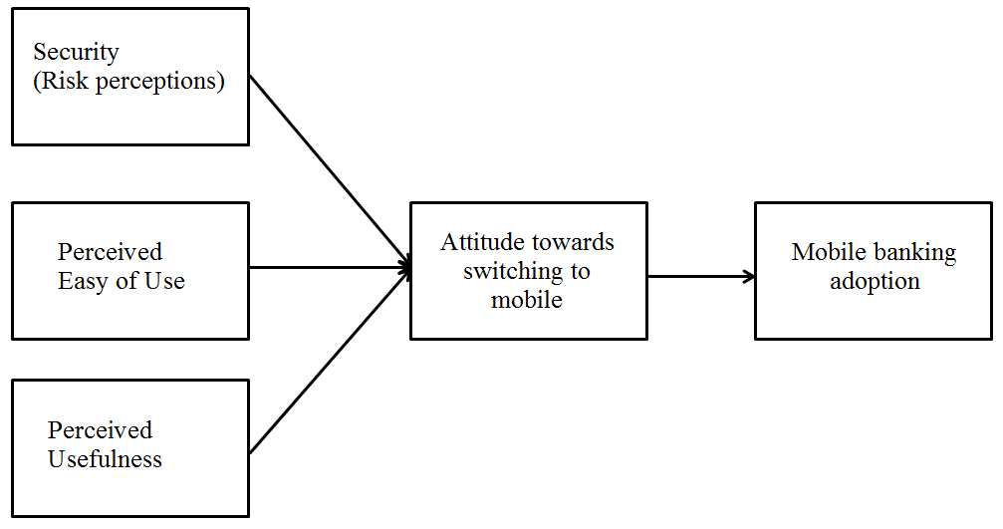

*Figure 4.* Proposed model to analyze the process (based on own concept)

The risk of using mobile banking services, the perceived ease of use of applications, the usefulness of available services, and changes in usage attitudes may be determinants of changes in the use of mobile banking services. Taking these aspects into account, we developed the following hypotheses:

H1: In the use of mobile banking services, there is likely to be significant effect of ‘Risk Perception’ of Mobile Banking on Attitude towards switching to mobile banking.

H2: There is likely to be significant effect of ‘Perceived Ease of Use’ of Mobile Banking on Attitude towards switching to mobile banking in the future.

H3: There is likely to be significant effect of ‘Perceived Usefulness’ of Mobile Banking on Attitude towards switching to mobile banking, which can make the financial processes of certain economic sectors more efficient.

H4: The emergence and proliferation of smart devices and phones is likely to be a significant effect of ‘Attitude towards switching to mobile banking’ on Mobile Banking service Adoption.

**3. Materials and Methods**

The analysis is a quantitative research based on correlational research design. The questionnaire was written in Arabic, and during the compilation of the questionnaire, the previous question sets were synthesized and updated for the study area. In our research, we focused on those banking customers who use banking services on average or above average. In the case of banking services, efficient and fast operation is important to them. The analysis sample number was set to 250 because we planned to ask additional specific questionnaires based on the results. According to the professional team (analytical economist, marketing specialist, computer engineer) participating in the research, the indicated sample number is a suitable basis for analytical purposes.

***3.1 Research design***

As has been mentioned this is a quantitative research based on correlational research design. Cause and effect relationship of variables were investigated. A questionnaire of 19 itemed Likert-type scale comprised of 5 subscales was designed to get the data. The subscales were; Perceived usefulness, Perceived ease of use, Attitude towards switching to Mobile Banking, Risk Perceptions and Intention to switch to Mobile Banking (Adoption). Each item was responded on range of responses from 1-5 (highly agreed to highly disagreed). Before collection of data, consent form was given that stated the purpose of the research and ensured confidentiality of each participant’s data. Before collection of data, consent form was given that stated the purpose of the research and ensured confidentiality of each participant’s data. The survey was submitted both electronically (by google doc. to their emails) and manually to the target population in the three main cities in Jordan, Amman, Zarqa and Irbid in 2019. We have submitted 250 questionnaire and get back 220 valid ones. The study involved sample of N=220 participants from which n=108 were male and n=112 were female participants who were selected using non-probability, convenient sampling technique. The participants’ age ranged from 21-70 years. We did not increase the number of participants to over 250 because we planned to establish further research programs.

***3.2 Data analysis***

Data was collected using a demographic form and a 19 itemed Likert-type scale comprised of 5 subscales. The subscales were: Perceived usefulness, Perceived ease of use, Attitude towards switching to Mobile Banking, Risk Perceptions and Intention to switch to Mobile Banking (Adoption). Each item was responded on range of responses from 1-5 (highly agreed to highly disagreed). Statistical Package for Social Sciences was used to analyse data and to test the hypotheses, regression analysis through enter method was used.

4. Results

In accordance with the aim of our study, we chose quantitative research methods to meet the objectives of the study. A questionnaire based on the presented mod-el was used for the studies. The applied descriptive statistic is a short descriptive coefficient that summarizes a particular set of data, which can be a representation of the entire mobile bank users. Descriptive statistics are broken down into measures of central trend and variability (distribution). Measurements of the central trend include mean, median, and mode, while measurements of variability include standard deviation, variance, minimum, and maximum variables. Following are the results of analyses: Demographics.

The above table shows that the majority of the sample was from age range 31-40 with 40 percentages and there were more female participants than males with 50.9 percentages. (Feedback from other comments indicated that women are more interested in easier use.)

In order to ensure the reliability (Cronbach’ Alpha) has been applied on the pilot sample consisting of (50) persons, Table (1) shows that.

*Table 1.*Descriptive statistics of the analysis

| **Demographic Variables** | | | |
| --- | --- | --- | --- |
|  |  | **Frequency** | **Percent** |
| **Gender** | Male | 108 | 49.1 |
| Female | 112 | 50.9 |
| **Age** | 21-30 | 13 | 5.9 |
|  | 31-40 | 88 | 40 |
|  | 41-50 | 79 | 35.9 |
|  | 51-60 | 35 | 15.9 |
|  | 61-70 | 2 | 0.90 |

Table (2) shows that the highest Cronbach' alpha value reached (0.91) for domain (5) “Mobile Banking service Adoption ", then was reach (0.90) for domain (3) “Perceived Usefulness ", and the lowest alpha value was (0.87) for domain (1) “Risk Perception ". But the total alpha values of “study tool " reached (0.99) this indicates to accept reliability. According to the general rules, a very high Cronbach Alpha (above 0.9) contains redundant elements. In our case, the mean value of 0.89 was considered a borderline case.

*Table 2.*The result of reliability (Cronbach Alpha)

|  |  |  |
| --- | --- | --- |
| **No** | **Domain** | **Cronbach Alpha** |
| 1 | Risk Perception | 0.87 |
| 2 | Perceived Ease of Use | 0.88 |
| 3 | Perceived Usefulness | 0.90 |
| 4 | Attitude towards switching to mobile banking | 0.89 |
| 5 | Mobile Banking service Adoption | 0.91 |
| **Total study tool** | | 0.89 |

Table (3) show that correlation Coefficient between (Risk Perception) and (Attitude towards switching to mobile banking) was reach (0.616) by sig (0.000). Correlation Coefficient between (Perceived Ease of Use) and (Attitude towards switching to mobile banking) was reach (0.655) by sig (0.000). Correlation Coefficient between (Perceived Usefulness) and (Attitude towards switching to mobile banking) was reach (0.712) by sig (0.000). Correlation Coefficient between (Mobile Banking services Adoption) and (Attitude towards switching to mobile banking) was reach (0.691) by sig (0.000).

*Table 3.*Pearson Correlation Coefficient between study variables

|  |  |  |
| --- | --- | --- |
|  | **Attitude towards switching to mobile banking** | |
| **Independent variable** | **Correlation Coefficient** | **Sig** |
| Risk Perception | 0.616** | 0.000 |
| Perceived Ease of Use | 0.655** | 0.000 |
| Perceived Usefulness | 0.712** | 0.000 |
| Mobile Banking service Adoption | 0.691** | 0.000 |

**Pearson Correlation Coefficient: To measure the relationship between study variables, correlation Coefficient were applied, Table (3)

**4.1. Statistical treatment**

The following statistical treatments through statistical software packages (SPSS v27) were used: Correlation Coefficient between study variables, the reliability (Cronbach' Alpha), Multiple Regressions analysis and Simple liner Regressions were applied

*Table 4.*Result of the (Multiple Regressions) analysis to detect the effect of ‘Risk Perception’ and ‘Perceived Ease of Use’ and ‘Perceived Usefulness’ of Mobile Banking on Attitude towards switching to mobile banking (n= 220)

|  |  |  |  |  |  |  |  |
| --- | --- | --- | --- | --- | --- | --- | --- |
| **Independent variable** | **"t" value** | **"t" sig** | **Beta** | **R** | **R2** | **"F" value** | **"F" sig** |
| **Risk Perception** | 3.858 | 0.031 | 0.163 | 0.824 | 0.679 | 138.077 | 0.000 |
| **Perceived Ease of Use** | 8.087 | 0.000 | 0.603 |
| **Perceived Usefulness** | 4.718 | 0.000 | 0.322 |

*Note: Dependent variable: Attitude towards switching to mobile banking*

Table (4) shows that there is a statistically significant effect at level (α≤0.05) for independent variables on Attitude towards switching to mobile banking, where "F" value reached (138.077) by statistically significant (0.000). (R) Value reached (0.824) and (R2) value reached (0.679). The results of study hypotheses depend on (t) value indicate to accept:

H1: In the use of mobile banking services, there is likely to be significant effect of ‘Risk Perception’ of Mobile Banking on Attitude towards switching to mobile banking. Where (t) value was (3.858) by significant (0.031).

H2: There is likely to be significant effect of ‘Perceived Ease of Use’ of Mobile Banking on Attitude towards switching to mobile banking in the future. Where (t) value was (8.087) by significant (0.00).

H3: There is likely to be significant effect of ‘Perceived Usefulness’ of Mobile Banking on Attitude towards switching to mobile banking, which can make the financial processes of certain economic sectors more efficient. Where (t) value was (4.718) by significant (0.00).

Therefore there are a statistically significant effect of ‘Risk Perception’, ‘Perceived Ease of Use’ and ‘Perceived Usefulness’ of Mobile Banking on Attitude towards switching to mobile banking.

H 4: The emergence and proliferation of smart devices and phones is likely to be a significant effect of ‘Attitude towards switching to mobile banking’ on Mobile Banking service Adoption.

To test the Hypothesis 4, and to detect the effect of ‘Attitude towards switching to mobile banking’ on Mobile Banking service Adoption, the (linear Regression) analysis was used; Tables (5) shows that.

*Table 5.*Result of the (Linear Regressions) to detect the effect of ‘Attitude towards switching to mobile banking’ on Mobile Banking service Adoption (n= 220)

|  |  |  |  |  |  |  |  |
| --- | --- | --- | --- | --- | --- | --- | --- |
| **Independent variable** | **"t" value** | **"t" sig** | **Beta** | **R** | **R2** | **"F" value** | **"F" sig** |
| **Attitude towards switching to mobile banking** | 24.699 | 0.000 | 0.869 | 0.869 | 0.755 | 110.025 | 0.000 |

*Note: Dependent variable: Mobile Banking service Adoption*

Table (5) shows that there are a statistically a significant effect at significant level (α≤0.05) for Attitude towards switching to mobile banking on Mobile Banking service Adoption, where "F" value reached (110.025) by statistically significant (0.000), (R) value reached (0.869), (R2) value reached (0.755). Therefore, accepted H4, which indicates to there is a statistically significant effect of ‘Attitude towards switching to mobile banking’ on Mobile Banking service Adoption.

5. Discussion

The results of this research concluded that there is a positive significant effect of Perceived Ease of Use and Perceived Usefulness of Mobile Banking on Mobile Banking Attitude. Similar results have been reported by the literature review [42]. Having the positive effects indicates that as the level of Perceived Ease of Use and Perceived Usefulness increases, the level of attitude towards Mobile Banking also increases. The results also show that there is a significant effect of Perceived Risk on attitude towards Mobile Banking which is not contrary to what is stated in the literature and hypothesis. It has been proved by recent studies that perceived risk negatively affects the customer’s intention to use mobile banking [43,44,45]. Even though this research was conducted in a different country than the researches that are considered in the literature review. This also gives a new direction for further research work. This research also concluded that Attitude towards switching to mobile banking has a positive significant effect on Intentions of Mobile Baking Adoption which means that as the consumers get a more positive attitude towards mobile banking, they are more likely to have intentions towards adopting mobile banking. The limitation of the study is relying on self-reported quantitative data only which can be overcome by using qualitative data, mobile internet statistics, and individual records on mobile banking to avoid subjectivity in further researches. Sales platforms and services connected to mobile applications are evolving at an unexpected rate. Similar phenomena can be observed in the case of mobile health applications, the consumer attitude follows the characteristics of our use in banking applications confirmed by our research. This direction of development also makes it possible to reduce the environmental impact of consumption and service systems. Efficient and economical solutions easily find their place in the economy [46,47[. Focusing on untapped and redundant resources is the basis of the green discourse around the sharing economy. Studies show that the sharing economy can facilitate restructuring towards more sustainable business and consumption patterns [48,49,50]. The growth of mobile banking services will allow banks to grow in emerging markets as well, reaching all channels where they can connect with players in the value chain. Due to the proliferation of mobile applications, customers are in constant communication with different service systems, so banks need to seriously review and redesign previous applications. It can also be stated that banks have a primary responsibility to change the way of thinking of individuals and to develop a sense of security [51]. The viral situation is good proof that we can use the resources we used to operate in different areas of the economy much more efficiently. The transformation of bank customer services is proceeding at a tremendous pace, which also means a general decrease in the quantitative use of resources [52]. Due to the virus situation, the transformed use of mobile banking services not only in the short term but also in the long term gives a prominent role in the changed services environment. The changing technological and service environment is also an effective means of reducing service fees.

6. Conclusions

Our results show convergences and differences with previous research results, confirming the unique characteristics of the rapidly developing Arab region. User behavior related to mobile banking is shaped by the combined effect of habit and culture. Mobile banking services could be very efficient and cost-effective tools in the future, which will have a fundamental impact on the infrastructures that provide banking services. Adoption models and frameworks are increasingly used in a variety of individual and organizational contexts to explore factors that influence the intent to use a particular technology, or the use itself. Examination of risk factors and perceived risk associated with use received limited attention in the research because we thought this was evident and well-justified. In the present research, we have highlighted that perceptual risk is highly dependent on the user environment. This needs to be further investigated from the point of view of the introduction of mobile banking services because it differs significantly from the characteristics of internet banking services, especially in the Arabian countries. The transformation process is rapid - however, the efficiency and speed of transformation may vary from country to country. The ability of the fast-growing economies of the Arab region to adapt is expected to be stronger than that of consumers in classical welfare states. Limitations of the research: the number of research samples and the indicators used are of course not suitable for drawing deep conclusions in the case of either sectoral differences or the characterization of individual countries in the Arab region. In line with the details mentioned in the methodological description, further analyzes were planned for different economic sectors and in several Arab countries as well.

**References**

1. **Zhang, Y., Weng, Q., Zhu, N.**, (2018**)** The relationships between electronic banking adoption and its antecedents: A meta-analytic study of the role of national culture. International Journal of Information Management, 40, 76–87. doi: 10.1016/j.ijinfomgt.2018.01.015
2. **Hamidi, H.; Safareeyeh, M.**, (2019) A model to analyze the effect of mobile banking adoption on customer interaction and satisfaction: A case study of m-banking in Iran. Telematics and Informatics 38, 166-181. doi:10.1016/j.tele.2018.09.008.
3. **Oliveira, T., Faria, M., Thomas, M. A., Popovič, A.**, (2014) Extending the understanding of mobile banking adoption: When UTAUT meets TTF and ITM. International Journal of Information Management, 34(5), 689-703.
4. **Munoz-Leiva, F., Climent-Climent, S., Liébana-Cabanillas, F.**, (2017) Determinants of intention to use the mobile banking apps: An extension of the classic TAM model. Spanish Journal of Marketing-ESIC,  21(1), 25-38.
5. **Szopiński, T. S.**, (2016) Factors affecting the adoption of online banking in Poland. Journal of Business Research, 69(11), 4763–4768. doi: 10.1016/j.jbusres.2016.04.027
6. **Ebie, S., Njoku, E.**, (2016) Extension of the Technology Acceptance Model (TAM) to the adoption of the electronic knowledge and skills framework (e-ksf) in the National Health Service (NHS). Journal of Applied Sciences and Development (JASD), 6(1 & 2).
7. **Shaikh, A. A.**, Karjaluoto, H., (2015) Mobile banking adoption: A literature review. Telematics and Informatics, 32(1), 129-142.
8. **Alalwan, A. A., Dwivedi, Y. K., Rana, N. P. P., Williams, M. D.**, (2016) Consumer adoption of mobile banking in Jordan. Journal of Enterprise Information Management, 29(1), 118–139. doi: 10.1108/jeim-04-2015-0035
9. **Gharaibeh, M. K., Arshad, M. R., Gharaibeh, N. K.**, (2019) Using the UTAUT2 Model to Determine Factors Affecting Adoption of Mobile Banking Services: A Qualitative Approach. International Journal of Interactive Mobile Technologies (IJIM),12(4), 123. doi: 10.3991/ijim.v12i4.8525
10. **Nzebile, P., Denadi., D.**, (2019) Digital Finance Country Report Jordan, (pp. 1–62). MEDA.
11. **Zhou, T., Lu, Y., Wang, B.**, (2010) Integrating TTF and UTAUT to explain mobile banking user adoption. Computers in Human Behavior,26(4), 760-767. doi:10.1016/j.chb.2010.01.013
12. **Chaouali,W; El Hedhli, K.**, (2019) Toward a Contagion-Based Model of Mobile Banking Adoption. International Journal of Bank Marketing 37, no. 1: 69–96. doi.org/10.1108/ijbm-05-2017-0096.
13. **Aboelmaged, M., Gebba, T. R.**, (2013) Mobile banking adoption: an examination of technology acceptance model and theory of planned behavior. International Journal of Business Research and Development,2(1).
14. **Sampat, B.**, (2016) Antecedents to Mobile Banking Adoption in India: An Extended TAM model. Wealth: International Journal of Money, Banking & Finance, 5(2).
15. **Lian, J.-W., Yen, D. C.**, (2013) To buy or not to buy experience goods online: Perspective of innovation adoption barriers. Computers in Human Behavior, 29(3), 665–672. doi: 10.1016/j.chb.2012.10.009
16. **Poushter, J., Stewart, R.**, (2016) Smartphone ownership and internet usage continues to climb in emerging economies. Pew Research Center
17. **Akturan, U.,Tezcan, N.**, (2012) Mobile banking adoption of the youth market: Perceptions and intentions. Marketing Intelligence & Planning, 30(4), 444-459.
18. **Püschel, J., Afonso Mazzon, J., Mauro C. Hernandez, J.**, (2010) Mobile banking: proposition of an integrated adoption intention framework. International Journal of bank marketing, 28(5), 389-409.
19. **Davis, F. D.**, (1989) Perceived usefulness, perceived ease of use, and user acceptance of information technology. MIS quarterly, 319-340.
20. **Park, E.; Lim, J.; Cho, Y.**, (2018) Understanding the Emergence and Social Acceptance of Electric Vehicles as Next-Generation Models for the Automobile Industry. Sustainability, 10, 662. doi: 10.3390/su10030662
21. **Weng, F; Rong-Jou, Y; H, Hann-Jang; Su, Hui-Mei.,** (2018) A TAM-Based Study of the Attitude towards Use Intention of Multimedia among School Teachers. Applied System Innovation 1, no. 3: 36. doi.org/10.3390/asi1030036.
22. **Giovanis, A; Athanasopoulou, P; Assimakopoulos,S & Christos Sarmaniotis,** (2019) Adoption of Mobile Banking Services.” International Journal of Bank Market-ing 37, no. 5: 1165–89. doi.org/10.1108/ijbm-08-2018-0200.
23. **Baptista, G., Oliveira, T.**, (2015) Understanding mobile banking: The unified theory of acceptance and use of technology combined with cultural moderators. Computers in Human Behavior, 50, 418-430.
24. **Lee, Y.-K., Park, J.-H., Chung, N., Blakeney, A.**, (2012) A unified perspective on the factors influencing usage intention toward mobile financial services. Journal of Business Research, 65(11), 1590–1599. doi: 10.1016/j.jbusres.2011.02.044
25. **Gupta, K. P., Manrai, R.**, (2019) Prioritizing Factors Affecting the Adoption of Mobile Financial Services in Emerging Markets-A Fuzzy AHP Approach. In Performance Prediction and Analytics of Fuzzy, Reliability and Queuing Models , pp. 55-81
26. **Tao, C. C., & Fan, C. C.**, (2017) A Modified Decomposed Theory of Planned Behaviour Model to Analyze User Intention towards Distance-Based Electronic Toll Collection Services. Promet-Traffic&Transportation,  29(1), 85-97.
27. **Yu, C. S.**, (2012) Factors affecting individuals to adopt mobile banking: Empirical evidence from the UTAUT model. Journal of Electronic Commerce Research, 13(2), 104.
28. **Luo, X., Li, H., Zhang, J., Shim, J. P.**, (2010) Examining multi-dimensional trust and multi-faceted risk in initial acceptance of emerging technologies: An empirical study of mobile banking services. Decision support systems, 49(2), 222-234.
29. **Laukkanen, T.**, (2014) Consumer Adoption / Rejection Decisions In Seemingly Similar Service Innovations: The Case Of The Internet And Mobile Banking, doi: 10.15444/gmc2014.04.02.02
30. **Granić, A. Marangunić, N.**, (2019) Technology acceptance model in educational con-text: A systematic literature review. British Journal of Educational Technology 50, 2572–2593. doi:10.1111/bjet.12864
31. **Rana, N. P., Barnard, D. J., Baabdullah, A. M., Rees, D., & Roderick, S.**,(2019) Exploring barriers of m-commerce adoption in SMEs in the UK: Developing a framework using ISM. International Journal of Information Management, 44, 141-153
32. **Martins, C., Oliveira, T., Popovič, A.**, (2014) Understanding the Internet banking adoption: A unified theory of acceptance and use of technology and perceived risk application. International Journal of Information Management,  34(1), 1-13.
33. **Venkatesh, V., Thong, J. Y., Xu, X.**, (2012) Consumer acceptance and use of information technology: extending the unified theory of acceptance and use of technology. MIS quarterly, 157-178.
34. **Venkatesh, Morris, Davis, Davis.**, (2003) User Acceptance of Information Technology: Toward a Unified View. MIS Quarterly, 27(3), 425. doi:10.2307/30036540
35. **Poupancas Featherman, M. S.,Pavlou, P. A.**, (2003) Predicting e-services adoption: A perceived risk facets perspective. International Journal of Human-Computer Studies, 59(4),451–474.
36. **Laukkanen, T.**, (2014) Consumer Adoption / Rejection Decisions In Seemingly Similar Service Innovations: The Case Of The Internet And Mobile Banking, doi: 10.15444/gmc2014.04.02.02
37. **Persada, S. F., Miraja, B.A Nadlifatin, R.**, (2019) Understanding the Generation Z Behavior on D-Learning: A Unified Theory of Acceptance and Use of Technology (UTAUT) Approach. International Journal of Emerging Technologies in Learning, Vol 14, No 05, <https://online-journals.org/index.php/i-jet/article/view/9993>
38. **Bagozzi, R. P.**, (2007) The legacy of the technology acceptance model and a proposal for a paradigm shift. Journal of the association for information systems, 8(4), 3.
39. **Dwivedi, Y. K., Rana, N. P., Jeyaraj, A., Clement, M., Williams, M. D.**, (2017) Re-examining the unified theory of acceptance and use of technology (UTAUT): Towards a revised theoretical model. Information Systems Frontiers, 1-16.
40. **Lee, M.,** (2009) Factors influencing the adoption of internet banking: An integration of TAM and TPB with perceived risk and perceived benefit. Electronic Commerce Research and Applications, 8(3), 130-141. doi:10.1016/j.elerap.2008.11.006
41. **Featherman ; M. S; amp; Pavlou, P. A.**, (2003) Predicting e-services adoption: A perceived risk facets perspective. International Journal of Human-Computer Studies 59(4), 451-474. doi:10.1016/s1071-5819(03)00111-3
42. **Rehman, Z.; Omar, S.; Zabri, S.; Lohana, S.**, (2019) Mobile Banking Adoption and its Determinants in Malaysia. International Journal of Innovative Technology and Exploring Engineering Regular Issue 9(1), 4231-4239. doi:10.35940/ijitee.l3015.119119
43. **Milchram, C.; Kaa, G. V.; Doorn, N.; Künneke, R.,** (2018) Moral Values as Factors for Social Acceptance of Smart Grid Technologies. Sustainability 10(8), 2703. doi:10.3390/su10082703
44. **Zhao, J.; Fang, S.; Jin, P.**, (2018) Modeling and Quantifying User Acceptance of Personalized Business Modes Based on TAM, Trust and Attitude. Sustainability 10(2), 356. doi:10.3390/su10020356
45. **Pires, I.M.; Marques, G.; Garcia, N.M.; Flórez-Revuelta, F.; Ponciano, V.; Oniani, S.**, (2020) A Research on the Classification and Applicability of the Mobile Health Applications. J. Personal. Med. 10, 11
46. **Geissdoerfer, M.; Savaget, P.; Bocken, N.M.; Hultink, E.J.**, (2017) The Circular Economy–A new sustainability paradigm? J. Clean. Prod. 143, 757–768
47. **Faria, R.; Lopes, I.; Pires, I.M.; Marques, G.; Fernandes, S.; Garcia, N.M.; Lucas, J.; Jevremović, A.; Zdravevski, E.; Trajkovik, V.**, (2020) Circular Economy for Clothes Using Web and Mobile Technologies—A Systematic Review and a Taxonomy Proposal. Information 11, 161.
48. **Grinevich, V.; Huber, F.; Karata¸s-Özkan, M.; Yavuz, Ç.**, (2019) Green entrepreneurship in the sharing economy: utilising multiplicity of institutional logics. Small Bus. Econ. 52, 859–876.
49. **Marques, M.S.G.; Pitarma, R.,** (2016) Smartphone Application for Enhanced Indoor Health Environments. J. Inf. Syst. Eng. Manag. 1, 4.
50. **Shuib, L.; Shamshirband, S.**; Ismail, M.H. (2015) A review of mobile pervasive learning: Applications and issues. Comput. Hum. Behav. 46, 239–244.
51. **Saji TG, Paul D.**, (2018) Behavioural Intention to the Use of Mobile Banking in Kerala: An Application of Extended Classical Technology Acceptance Model. Metamorphosis. 17(2):111-119.
52. **Cordova-Pizarro, D.; Aguilar-Barajas, I.; Rodriguez, C.A.; Romero, D.**, (2020) Circular Economy in Mexico’s Electronic and Cell Phone Industry: Recent Evidence of Consumer Behavior. Appl. Sci. 10, 7744.